The Corporate Moose

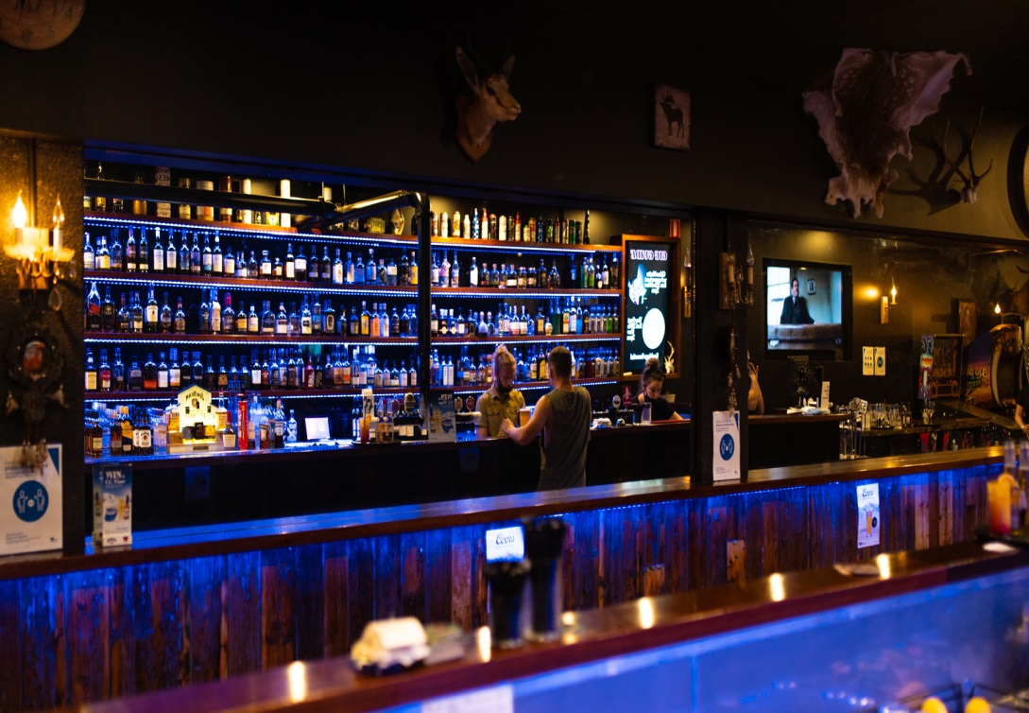
A Little bit about us:

The Corporate Moose opened in September 2015, offering an alternative venue outside of the traditional pub and gaming venues.
We are committed to providing a venue where everyone is treated equally and inclusively and can enjoy a beverage and meal in a pleasant and family friendly social atmosphere.
We pride ourselves in offering “something different” for our customers, with various experiences available in the venue including an undercover alfresco area, beer garden, dining room and 2 fully stocked bar areas.
Boasting an extensive menu with dishes to satisfy all tastes, great cocktails, the regions widest range of whisky’s, liqueurs, craft beers & draught beers as well as impressive music sourced locally &from around the country.

Contact: Marissa Burrows
The Corporate Moose
34 Langtree Ave, Mildura
(03) 5022 8608
thebar@thecorpmoose.com.au

Beverages

Drinks on Consumption
This option allows the function holder to open a bar tab using a valid credit card or pre-paying their chosen amount. The function holder can set their own limit and specify the drinks that are on offer. We can supply your function with wristbands & keep you updated of the limit throughout the night.

Cash Bar
All guests pay for their own drinks individually at the bar.

Drinks Packages—30+ guests*
Choose from our different drink packages, all packages are priced per head for the duration chosen. Patrons will be supplied with a maximum of two drinks at a time.

+Add a list of 5 House Cocktails to any package for an extra $20 pp

STANDARD PACKAGE
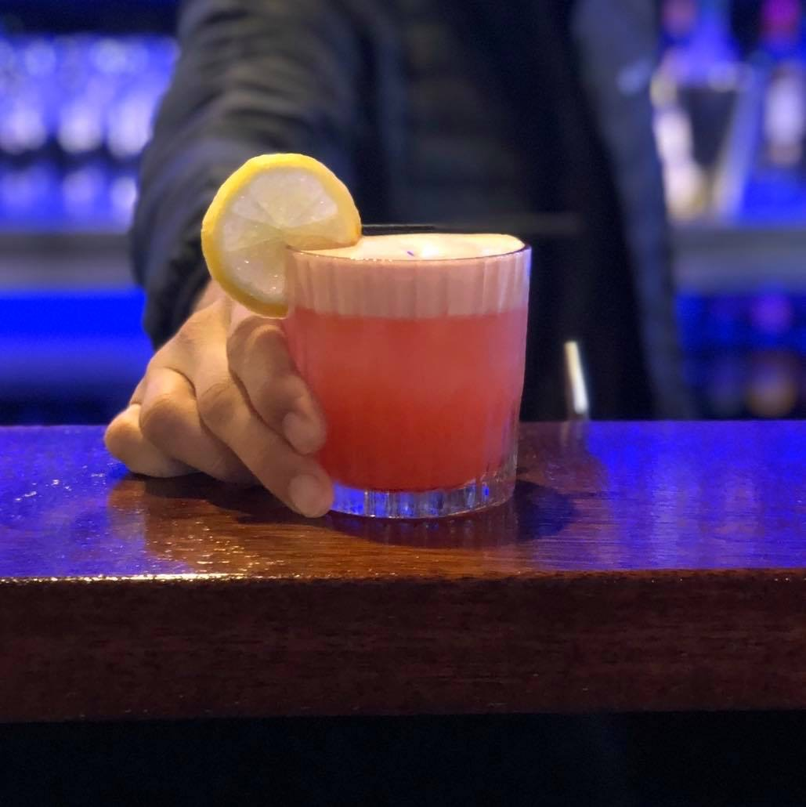
2-hour length - $45pp 3-hourlength - $65pp House Wine

Draft Beer
Soft Drink & Juice

SUPERIOR PACKAGE
2-hour length - $50pp 3-hour length - $70pp House Wine

Draft Beer
Bottled Beers & Cider Soft Drink & Juice

DELUXE PACKAGE
2-hour length - $75pp 3-hourlength $95pp House Wine

Draft Beer
Bottled Beers & Cider Soft Drink & Juice Basic Spirits

* Please ask functions manager for finer details on drinks in each category
*Responsible service of alcohol applies

Canapés

Pork Sliders
Pulled pork, BBQ sauce, aioli with lettuce and cheese
on a brioche bun
$6.50 per piece
$150 per 25-piece platter
$275 per 50-piece platter

Beef & Ketchup Sliders
Beef patty with cheese, ketchup, and lettuce on a brioche bun
$6.50 per piece
$150 per 25-piece platter
$275 per 50-piece platter

Chicken & Aioli Sliders
Southern fried fillet with cheese, aioli, and lettuce on a brioche bun
$6.50 per piece
$150 per 25-piece platter
$275 per 50-piece platter

Chorizo Sliders
Smoked chorizo, lettuce, cheese & aioli on a brioche bun
$6.50 per piece
$150 per 25-piece platter
$275 per 50-piece platter

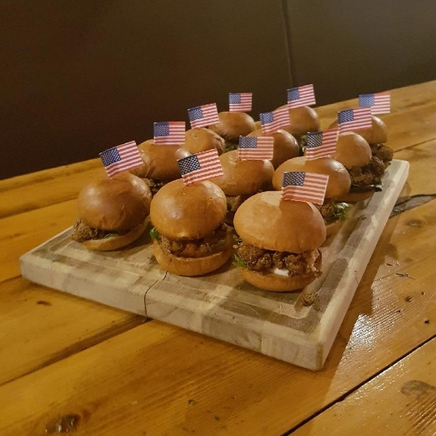
Smoked Buffalo Chicken Wings (GF)
Marinated in Franks Hot sauce with lemon and paprika, served
with Ranch Sauce
$3 per piece
$70 per 25-piece platter
$135 per 50-piece platter

Mixed Sandwiches
Chef’s selection of gourmet sandwiches
$7 per piece
$160 per 25-piece platter
$300 per 50-piece platter

Grilled Corn (GF/V)
Grilled corn, slathered in garlic butter and parmesan
$3.00 per piece
$55 per 20-piece platter
$100 per 40-piece platter

Squid (GF)
Lightly fried squid pieces, tossed in lemon pepper, served
with aioli
$1.50 per piece
$35 per 25-piece platter
$65 per 50-piece platter

Dagwood Dogs

We can cater to those of all different tastes.
Please let us know if you
have any dietary requirements and we can organize a special menu for you.
Mini frankfurters in a corn dog batter, fried and
served with ketchup and mustard
$3.00 per piece
$70 per 25-piece platter
$135 per 50-piece platter

Cheesy Garlic Bread (V)
Toasted Turkish bread topped with garlic butter and cheese
$1.75 per piece
$30 per 20-piece platter
$55 per 40-piece platter

Bruschetta (V)
Toasted Turkish bread with tomato, red onion, basil, goats cheese,
olive oil and balsamic glaze
$3.00 per piece
$55 per 20-piece platter
$100 per 40-piece platter

Chicken/ Beef Skewers (GF/V)
Skewer of Meat onion and capsicum, drizzled with olive oil and balsamic glaze
$4 per piece
$95 per 25-piece platter
$180 per 50-piece platter

Something More Substantial
3 Course $45 per person
3 Course alternate drop $50 per person
2 Course $ 35 per person
2 Course alternate drop $40 per person

We can cater to those of all different tastes.
Please let us know if you
have any dietary requirements and we can organize a special menu for you.
ENTREE:
(Please choose 1 of the following or 2 for alternate drop)

Garlic Bread (V)
Toasted Turkish bread topped with garlic butter

Bruschetta (V)
Toasted Turkish bread with tomato, red onion, basil, goats cheese, olive oil and balsamic glaze

Grilled Corn (GF/V)
Grilled corn, slathered in garlic butter and parmesan

MAIN:
(Please choose 1 of the following or 2 for alternate drop)

Breaded Chicken
Crumbed chicken schnitzel served with chips, salad, and gravy

Smoked Beef Brisket (GF)
Cold smoked, slow roasted, smothered in BBQ sauce served with chips and salad

Beer Battered Barramundi (GFA)
House battered barramundi served with chips, salad, aioli, and lemon wedge

DESSERT:

(Please choose 1 of the following or 2 for alternate drop)

Warm Triple Chocolate Brownie (GF)
Served with chocolate ganache, chocolate ice cream and whipped cream

New York Baked Cheesecake
Served with warm berry compote, vanilla ice cream and whipped cream

From the Smoker
Share Platter $40 (share between 2)
Smoked wings, grilled corn, corn dog nuggets, cheese dip, Buffalo cauliflower
and Chorizo sliders.

The Moose Board $80
Pork ribs, pulled pork, buffalo wings, smoked brisket, cheese kransky pieces
& jalapeno poppers served with BBQ & ranch sauces.

Texas Style Smoked Pork Ribs 500g $39
House smoked and smothered in BBQ sauce, its 500 grams of
Melt in your mouth Bliss, served with house made slaw and corn on the cob

We can cater to those of all different tastes.
Please let us know if you
have any dietary requirements and we can organize a special menu for you.
Pre-Ordered
Snacks

If you’re not sure how many are coming, or who is going to be eating at your event, pre-ordered snacks are a great idea for you.
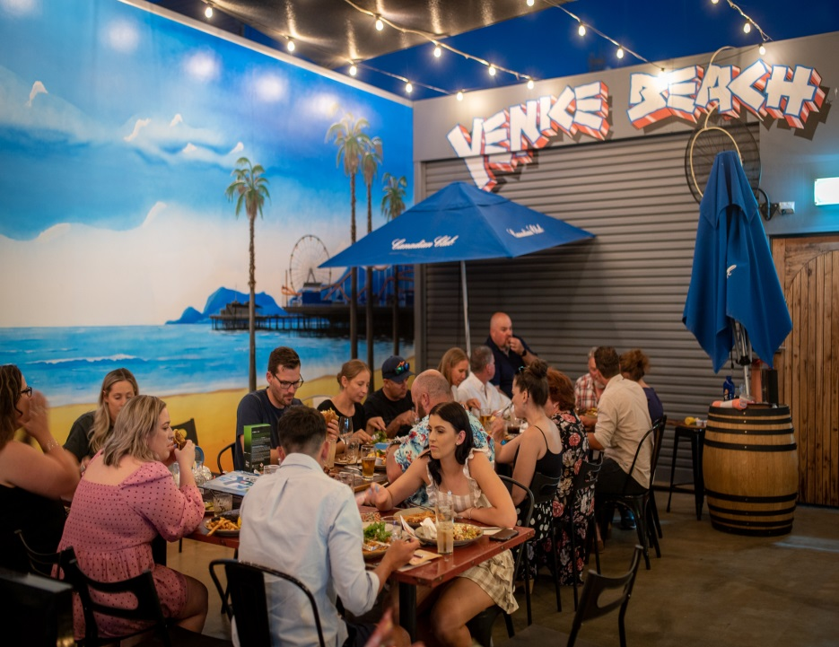
Nachos $16
With cheese, salsa, guacamole, and sour cream

Bowls of Fries $8
Beer battered fries served with aioli

Bowls of Sweet Potato Chips $11
Served with aioli

Bowls of Onion Rings $7
Served with aioli

Bowls of Wedges $12
Served with sweet chili and sour cream

Maple Loaded Fries $16
Served with Maple bacon, ranch, and cheese

Salsa Loaded Fries $16
Diced tomato, onion, corn cheddar cheese, sour cream & guacamole.

Mac & Cheese $7
House Made

American Cheese Dip $7
Served with tortilla chips.

Other Details…

AV & Entertainment
Venue house music will be played within the function spaces, personalised selections or requests are available in the rear bar area. If the function is booked on a Friday or Saturday night you will have our live musicians playing, if planned early enough we may be able to book an act you’d like (depending if they correspond with our vibe/quality/genre).
Functions booked in the backstage area on public holidays, Friday or Saturday nights will only be exclusive from the start time until 9pm unless otherwise organised with the function coordinator.

There is a big projector screen available for personal use
i.e., photo slideshows.

Decorations
If you are bringing decorations for your function, please consult the functions Coordinator to ensure these will be permitted in the venue Please note that confetti or table scatters of any kind are not permitted. Please do not hesitate to ask any questions about this.

BYO policy
No outside food or beverages will be permitted onto our premises.
Birthday cakes, however, are the exception to this rule.

Payment Policy
- Full payment of all food choices must be finalised to confirm your booking, at the latest, 7 days prior to the event.
- Any bookings made without payment will be tentative only, and we may accept other bookings in the meantime.
- If you need an invoice, please supply the full address details of the business we need to send it to.
- No refunds available within 48 hours of function.

Terms and Conditions
- The Corporate Moose complies with the VCGLR Responsible Service of Alcohol and may refuse to serve alcohol to any person who they believe to be intoxicated or acting in disorderly manner.
In accordance with liquor licensing laws, minors are only permitted on the premises in the direct company of their parent or legal guardian. At no time is a minor permitted to consume alcohol on the premises.
- Organisers are financially responsible for any damages to property, building, furniture, fixtures, and fittings during their function, if proved to be caused by one of their guests.
- We are complying with all Covid Safe requirements and as such patron capacity, density quotients and operational rules apply. All patrons are expected to adhere to directions provided and failure to comply may result in you being asked to leave.
- All functions are not private, unless organised otherwise.

Opening Hours
Monday - Friday Noon till Late
Saturday & Sunday: Noon till Late

